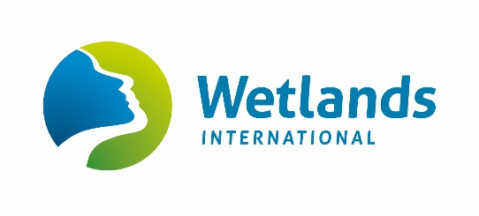

Please read the terms of use before submitting this form to tom.langendoen@wetlands.org

IWC Data Request Form

CONTACT NAME:  ADDRESS:  TEL: FAX:  E-MAIL: |  | PROJECT TITLE:
 |  | Are you carrying out this work in a professional or voluntary capacity?
What is your deadline for receiving the data?

Please give details (especially regarding potential conservation benefits) of the purpose for which you require the data (continue on separate sheet if necessary).

Please give details of the data or data analysis you require.

In what form do you wish to receive the data?

Will your use of the data be part of a commercial project? If so, give details.

I agree to abide by the IWC data access policy for use and understand that this forms the basis of a legally binding contract with Wetlands International.

Signed: | Date:

Terms of use for International Waterbird Census data

This document provides the terms of use for data and related information collected and analysed by Wetlands International under the International Waterbird Census. Wetlands International will provide only certain (usually, processed) multinational data. Requests for single-country site level data will be referred to the national data providers.

- The data are supplied only for conservation purposes, scientific analysis or research.
- Reproduction of the dataset or products derived from it, either whole or in part, for direct financial gain is prohibited without prior written permission of Wetlands International.
- The recipient will not pass the original datasets on to third parties and will direct all such requests for use of the data back to Wetlands International.
- The recipient will not publish the data in their original format, either whole or in part, on a website, FTP site, CD, memory stick or any other media.
- The recipient of the data will provide a full acknowledgement of national contributors and appropriate citation in any materials or publications derived in part or in whole from the data.
- For any publications making significant use of the data, Wetlands International reserves the right to comment on the analysis prior to publication. Where appropriate, Wetlands International can provide additional guidance on request to aid in the correct use and interpretation of the data.
- Wetlands International endeavours to maintain accurate and up-to-date data at all times, but can accept no responsibility for the consequences of errors or omissions in the data, for misuse of the data by any organisation or individual, or for any damage done to computing systems into which the data are entered (see Disclaimer below).
- Two copies of all products using data supplied by Wetlands International will be sent, free of charge, to the Wetlands International HQ at Wetlands International, P.O. Box 471, 6700 AL Wageningen, The Netherlands or by email to: iwc@wetlands.org. Products will also be sent to relevant national coordinators if requested.

Disclaimer
Wetlands International makes no warranties or representations, express or implied, regarding the use of the material appearing in this dataset with regard to their correctness, reliability, accuracy, or otherwise. The material and geographic designations in this dataset do not imply the expressions of any opinion whatsoever on the part of Wetlands International concerning the legal status of any country, territory or area, nor concerning the delimitation of its frontiers or boundaries. Neither Wetlands International nor its affiliated or related entities or its content providers shall be responsible or liable to any person, firm or corporation for any loss, damage, injury, claim or liability of any kind or character based on or resulting from any information contained in the dataset. Wetlands International may update or make changes to the data provided at any time without notice; however, Wetlands International makes no commitment to update the information contained therein.

Errors and omissions
Wetlands International endeavours to maintain accurate and up-to-date data at all times. However, if errors or omissions are identified, the user should notify Wetlands International so that they can be corrected in future releases of the data. Users can contact Wetlands International using the details below.

Email: iwc@wetlands.org
Telephone: +31 (0) 318 660 910
Fax: +31 (0) 318 660 950
Postal Address: Wetlands International, P.O. Box 471, 6700 AL Wageningen, The Netherlands

